

LENANA SCHOOL 2025 PREDICTION
POSSIBLE KCSE EXAM
BIOLOGY
PRACTICAL
231/3
PAPER 3
TIME: 1¾ HOURS

NAME……………………………………………………………………………………….
SCHOOL……………………………………………… SIGN………………………..
INDEX NO……………………………………………. ADM NO……………………

Kenya Certificate of Secondary Education.

INSTRUCTIONS TO CANDIDATES
- Answer all the questions in the spaces provided.
- You are required to spend the first 15 minutes of the 1 ¾ hours allowed for this paper reading the whole paper carefully before commencing your work.
- Additional pages must not be inserted.

FOR EXAMINERS USE ONLY.
Question | Maximum score | Candidates score
1 | 17
2 | 09
3 | 14
Total score | 40

Answer all the questions in the spaces provided.
1. You are provided with specimen P and Q. Examine them carefully and answer the questions that follow.
(a). State three observable differences between P and Q. (3mks)
Specimen P | Specimen Q

(b) Identify the parts of the flower from which specimen P and Q developed. (2mks)
P ----------------------------------------------------------------------------------------------------------------
Q ---------------------------------------------------------------------------------------------------------------

(c i). Make a longitudinal section of specimen P. Draw a well-labelled diagram of one half with all its Contents intact. (4mks)

(ii). State the functions of any two structures in (c) (i) above. (2mks)
.....................................................................................................................
.....................................................................................................................
.....................................................................................................................

(d). Using a mortar and pestle crush specimen Q, add 5ml distilled water to make a solution Q and carry out appropriate tests using the reagents provided. (6mks)
Test | Procedure | Observation | Conclusion

2. Study the photos below.
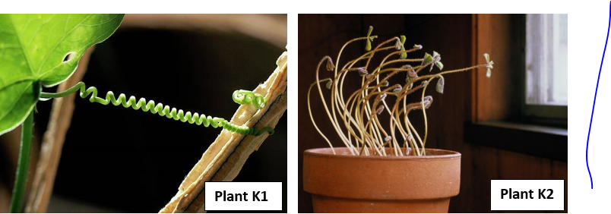

a) Name:-
i) The stimulus operating in Plant K1. (1mk)
.....................................................................................................................

ii) The type of response being investigated in Plant K2. (1mk)
.....................................................................................................................

iii) Suggest a control set up for Plant K2 investigation. (1mk)
.....................................................................................................................
.....................................................................................................................

b) Describe the role of auxins in the response exhibited by Plant K1. (4mks)
.....................................................................................................................
.....................................................................................................................
.....................................................................................................................
.....................................................................................................................
.....................................................................................................................
.....................................................................................................................

c) What is the biological value of the tropisms evident in: -
i) Plant K1 (1mk)
.....................................................................................................................
.....................................................................................................................

ii) Plant K2 (1mk)
.....................................................................................................................
.....................................................................................................................

3. Below are photos of of a certain arthropod at different stages of its life cycle.
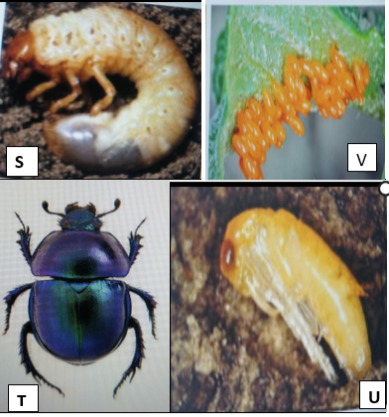
a) Identify the stage of the life cycle represented by organism S. (1mk)
.....................................................................................................................

b i) Name the stage that immediately preceed and succeed organism S in the life cycle. (2mks)
Preceeding stage
.....................................................................................................................
Succeeding stage.
.....................................................................................................................

ii) What name is given to the complete life cycle of the arthropod? (1mk)
.....................................................................................................................

c) Name the gaseous exchange system of orgaism S. Give a visible feature that supports your answer. (2mks)
.....................................................................................................................
.....................................................................................................................
.....................................................................................................................
d i) What type of food does organisms S feed on? Give a reason to support your answer. (2mks)
.....................................................................................................................
.....................................................................................................................
.....................................................................................................................

ii) State the significance of stage U in the life cycle of the beetle. (2mks)
.....................................................................................................................
.....................................................................................................................
.....................................................................................................................

iii)How is specimen T adapted to locomotion in its habitat ? (2mks)
.....................................................................................................................
.....................................................................................................................
.....................................................................................................................

e) State the role of the following in the life cycle of the arthropods. (2mks)
i) Juvinile hormone.
.....................................................................................................................
.....................................................................................................................

ii) Moulting stimulating hormone.
.....................................................................................................................
.....................................................................................................................

